Week 5 Fruit of the spirit
Kindness
Craft: Draw around children’s hands ask them what they can do to help others. Get the children to draw and stick onto hands. Adult writes what they can help with.
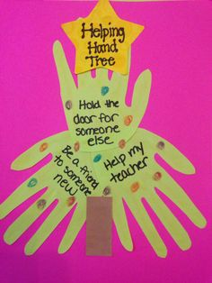
Discussion: Talk to the children about who they can help, and who helps them. Like their mums and dads, family. God can help them too and they can talk to God.

Use the bubbles to encourage them to come to the carpet.
Song this term……
God’s love is higher than the mountains (point up)
Deeper than the sea (point down)
Wider than the biggest hill (stretch arms wide)
Is how much God loves me (cross arms over chest)
Please feel free to use the song board again this term

