Week 2 Fruit of the spirit
Joy
Craft:
Use different coloured craft material to stick onto the word joy.
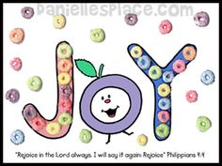
Discussion: Talk to the children about things that make them happy.
Song: Happy and you know it.

Use the bubbles to encourage them to come to the carpet.
Song this term……
God’s love is higher than the mountains (point up)
Deeper than the sea (point down)
Wider than the biggest hill (stretch arms wide)
Is how much God loves me (cross arms over chest)
Please feel free to use the song board again this term

