Week 6 Fruit of the spirit
Gentleness
Craft: Finger paint a picture of grapes.
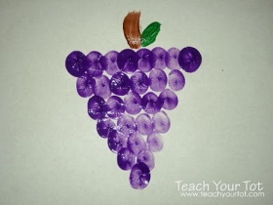
Discussion: Have different things like animals, the babies out talk with the children that we have to be gentle. If you can get other things to show the children how to be gentle for example if you know someone in church with a baby maybe ask them to come in and show they have to be gentle…..
Use the bubbles to encourage them to come to the carpet.
Song this term……
God’s love is higher than the mountains (point up)
Deeper than the sea (point down)
Wider than the biggest hill (stretch arms wide)
Is how much God loves me (cross arms over chest)
Please feel free to use the song board again this term

