Sunday 5th November
Aim: To talk with the children to let them know we are all friends of Gods.
Craft:
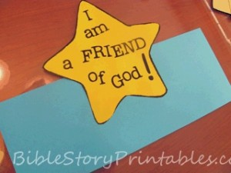
Make hats for the children to wear.

Songtime:

