Smarties Material 14th October
Intimacy- The Living Word part 2
Bible story- Acts 9:1-19
Remember last week we learnt about our imaginations and how we can picture things like on a TV screen? Let’s do that while we listen to this story. Close your eyes and as I read, picture what is going on in your head.
Read Acts 9:1-19. Saul’s Conversion.
This story comes after Jesus was killed, came back to life and after He left the disciples to return to His Father God. So we know people can meet Jesus because that’s what happened to Saul. Meeting Jesus was so powerful for Saul that he turned his life around, chose to follow Jesus and changed his name. So meeting with Jesus is really powerful.
Now listen to this story…
A lady, not long ago, met with Jesus and it changed her life too. She had been suffering with terrible headaches for many years. These headaches are called migraines and they would last for days. Her head would hurt so much it hurt to put it on a pillow. She had to lie in a dark room and she felt like throwing up for days. It was horrible. She had to take very strong medicine.
One day, one of these headaches started but she wasn’t at home. She was in a meeting with some other Christians. The leader of the meeting asked everyone to take some time to imagine a Bible story just like we just did. The lady did this and, in the story, she imagined herself sitting at Jesus’ feet. In her mind she imagined laying her head on Jesus’ knee. Jesus put His hand on her head. Neither Jesus or the lady said anything. Then, after a while, He took His hand away and said, “Now go.” In her mind she saw herself get up and leave the house where Jesus was and walk away.
She opened her eyes and realised that her headache was gone! What’s more, the headaches have never come back and she was able to stop her medicine, which really surprised the doctors!
If you could meet Jesus like that lady did, what questions would you ask Him?
Response- 5-10 mins
Based on Matthew 19:13-15
We’re going to take some time now to listen to a Bible story and, if you would like, you can imagine yourself in this story. You are one of the children who will meet Jesus. So, in the middle of the story, I’m going to stop and you’re going to have some time to be with Jesus. It’s going to be just you and Him. You’ll be able to ask Him questions you thought of or talk to Him about anything. If you can’t think of anything to say, do what the lady did in the testimony and just sit with Him in your imagination.
The sun was shining, the day was still cool because it was still early in the morning, but there was every chance that today was going to be hot and dusty as the sun rose further in the sky. The kids on the street had been talking the day before about a man who had come to our town who could do amazing things. They said this man could heal people who were sick; even bring them back from the dead! So we’d all agreed to meet up in the street at 8 o’clock and a whole bunch of us were going to go and see if we could find this man called Jesus.
Stepping out of the house, I could feel the building heat of the day and the sand on the road had already worked its way into my sandals. There were shouts of, ‘Hi,’ and ‘Hello,’ as all the kids gathered together. There was excitement in the air; today was a day for an adventure.
It wasn’t difficult to work out where this man was; there were crowds of people travelling on the road, all headed for the same place. We just tagged along, playing games as we went, running in and out of people and chasing each other.
We arrived, and you could see loads of people; lots of them were adults and they were much bigger than us. We pushed our way to the front of the crowd. It was hard, sweaty work but we got to the front eventually – sometimes being small really helps. Then, after all that effort, a guy called Peter, a friend of Jesus’, said we couldn’t go any nearer. He said Jesus was too busy to deal with little kids.
Then Jesus stood up suddenly and said to His followers, “Leave those children alone! Don’t stop them coming through. The kingdom of heaven belongs to these children.” Jesus made some space around Him just for us. He called each of us by name and, one by one, we had a chance to sit and chat with Him on our own.
Now imagine yourself sitting at Jesus’ feet and talking to Him (Put time in here for God to move.)
It’s time to go now. So you stand up and start to walk away from Jesus in the crowd.
- Does anyone want to share what Jesus said to them or how that felt?
- Did you enjoy being in the story? Was it easy to imagine?
Craft- Colouring sheet

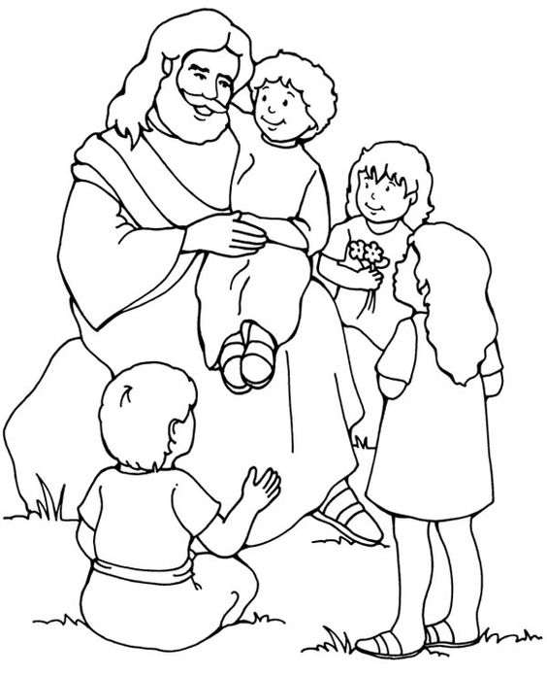
Call to Me and I will answer you Jeremiah 33:3a

