Riverside Young Vineyard Jellies Material
Simply Jesus
Week 4: Jesus our teacher

Worship | Sing “The wise man built his house upon the rock”  The song (with actions) can be found on youtube:  https://www.youtube.com/watch?v=zAjEjxX-DhA
Game/ Play | Build houses with duplo/ building blocks
Story | Read The story of the two houses in the Rhyme Bible Storybook (Page 336)
Teaching/  Discussion | Talk about how Jesus teaches us lots of things that will help us in life. If we want to do well the best thing to do is to listen to Jesus’ teachings in the Bible.
Chat & Catch  (Prayer) | Leaders- Take time praying for each child as they play or do the craft. Pray that as they grow and learn, they will listen to Jesus’ teaching and grow stronger and wiser everyday. Pray out loud and don’t be afraid to proclaim any words/pictures that you feel God gives you for them. You may even want to write these down and hand them to the parents at the end of the session.
Craft/  Activity | Colouring page- see below

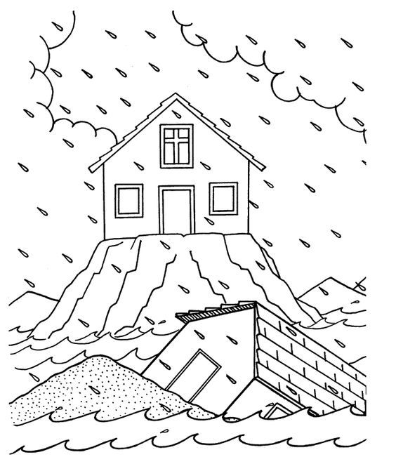

“Listen and do the things I say,
And you’ll grow wiser everyday!”
(Paraphrased Matt 7:24)

