Riverside Young Vineyard Teaching Material
Simply Jesus
Week 2: Jesus, God’s Son

Worship | 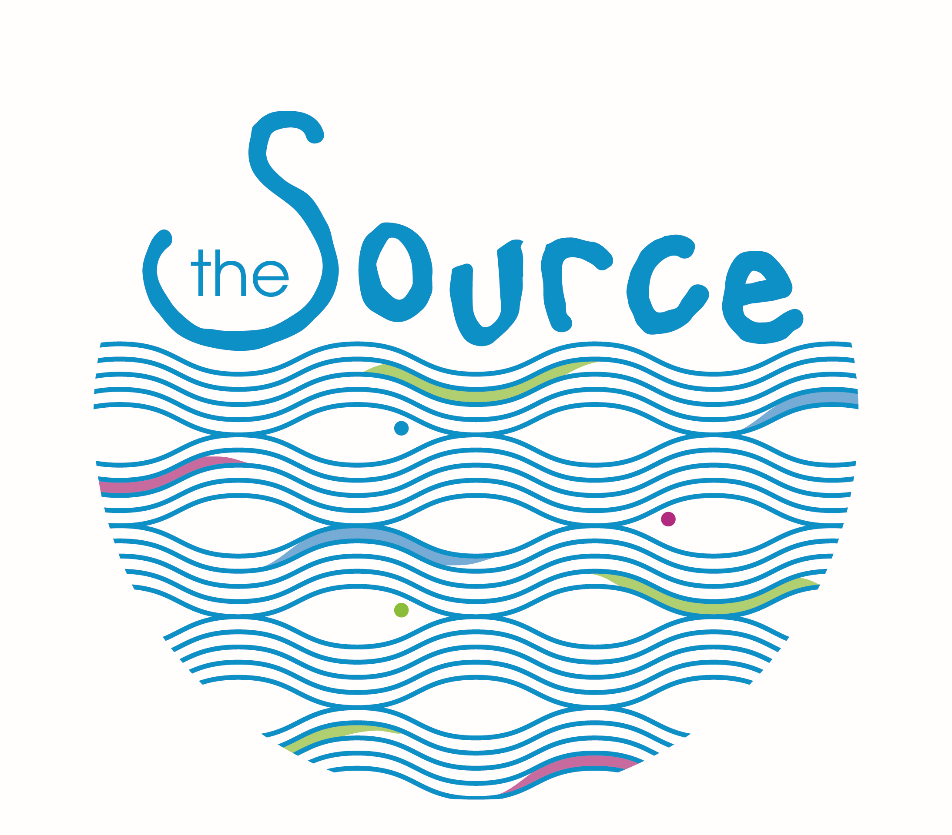
Story | Show some pictures/video from Baptism service at Riverside- Ask Children what it is, what happens, why we do it. Interview a leader/child who has been baptised- why?, how did you feel? Etc. Explain that we are going to look at the story of Jesus’ Baptism. In the Story God says that Jesus is His Son, We are going to think about how we are children of God and how this changes how we think, feel and live.
Game | Who am I?  Older groups: Write famous people’s names (that the kids will know!) on stickers before the session. Stick a name on everyone's forehead without them looking at it and when everyone has a name the game can start. The aim of the game is to guess who you are by only asking yes or no questions.  To make the game longer… Tell the kids that there is a 10 minute time limit on the game. As soon as they have guessed their name correctly they can stick it on their top and get another one from the leader. The person who has the most names on their top at the end is the winner.  Younger Groups: Sit all the children on the carpet and stand up the front. Act out an animal and get the kids to shout out what they think you are. Then the person who guessed correctly first gets to have a chance at acting out another animal. Keep going until everyone who wants to have a go has had a go.
Teaching/  Discussion | Read Mark 1:9-11  Jesus went to get baptised by John the Baptist. He did this as a sign that he was following God. We also do the same thing- When we get baptised we are showing everyone that we follow God.  As Jesus came up out of the water the Holy Spirit descends on him like a dove and they hear a voice saying ‘this is My Son, whom I love, with Him I am well pleased.’  - Who is speaking? How does this make Jesus feel?  - How do you know when someone loves you? What does it feel/look like?  - Jesus is God’s Son- God loves Him and is pleased with Him even before He has done any of His ministry or miracles! Sometimes we can forget that God loves us because we are His children not because of what we do for Him.  - Later on Jesus does many great things for God- how does it help to know he is loved?  Read 1 John 3:1-2  When we say ‘yes’ to following Jesus, we too become children of God.  God loves us so much and this should help us to live for him.  - How does it feel to know you are a child of God?  You no longer have to worry or fear because God loves you and is pleased with you.  If you have not said ‘yes’ to Jesus yet but would like to, we’re going to say a prayer asking God to adopt us into his family. If you are already following Jesus then you can say this prayer as a thank you for all God has done for you.  “God thank you that you love me. Thank you that you are pleased with me. I choose to follow you. I’m sorry for not following you before and for the wrong things I have done. Please forgive me and help me to follow you from now on. Thank you that we are your children and that you love us so much. Amen”
Craft/  Activity | “The Holy Spirit came down on Him like a dove” Mark 1:10b  You will need:  - Template of dove’s body photocopied onto white card, 1 per child  - Scissors  - Craft Knife (ADULTS ONLY)  - White paper, 1 per child  - Orange and Black Felt Tips  - Ribbon/string  - Hole punch  1. Cut out the body of the dove and, with the craft knife, cut along the dotted line.  2. Add the beak and the eyes to both sides of the bird.  3. Fold an A4 piece of paper up like a fan and then carefully push it through the opening in the body. Fan out the wings.  4. Punch a hole just above the wings and thread through some ribbon so it can be hung up.  Take this home as a reminder that Holy Spirit is with us just as He was with Jesus
Chat & Catch | Just as God spoke in the passage saying ‘This is my son whom I love, with Him I am well pleased’ He loves to speak to us too. We are going to spend some quiet moments talking to God and listening to him. You might want to sit on the floor or find a space in the room or close your eyes and hold out your hands.  Have some quiet music in the background and hand out prayer books/ paper if you want. Give the children some time to listen and pray. Then at the end, read these words over them to finish:  “God says, “These are my children, who I love, with them I am well pleased.” Or you may want to go around each child and say this phrase over them using their name. (e.g. God says “John is my child, with him I am well pleased.”)
Weekly Challenge | Imagine tomorrow: What would you do differently if you knew you were loved completely? What would you try knowing if you failed, God still loves you? Ask God help you live like this: No fear.

