Riverside Young Vineyard Teaching Material
Simply Jesus
Week 1: Jesus of History

Worship
Story | Dave will introduce Simply Jesus series and explain about Jesus cards to collect. Will then talk about historical evidence for Jesus.
Game | Use the attached images of significant events in the Bible.  Cut them up and shuffle them. Get a child to pick one and show everyone. Ask another child to come and pick another one from the deck and show everyone. Ask the children to guess if they think it happened before the first one or after. Get the child to stand where they say. Then choose another child to come up and go through the same process. As more and more get added it gets harder to guess where each one fits in and they may all need to shuffle around a bit. By the end you should have the children holding the cards all standing in one long line to represent the timeline of the bible.  (Here is the correct order!...)  - Adam and Eve  - Noah  - Joseph and his Brothers  - Moses  - David kills Goliath  - Jesus is born  - Jesus turns water into wine  - Jesus raises Lazarus from the dead  - Judas betrays Jesus  - Jesus is killed on the cross  - Jesus raises back to life  - Holy Spirit comes at pentecost
Teaching/  Discussion | Read Luke 1 v1-4.  Luke’s account of Jesus’ life, as well as all the other books in the bible, gives us a picture of who Jesus was and what He did for us. Although Jesus was on earth a long time ago His story is still shared around the world today and helps us as Christians to know how to follow Him and be more like Him. Jesus’ story becomes our story when we become Christians. We each have a story of our own to tell and when we become Christians we often share with people our ‘testimony’. This is a fancy word for your story of how you became a Christian.  All Leaders- Share your testimonies!  If there are any others in the room that would like to have a go at sharing their testimony that would be great. It is really good if we can practice sharing our testimony so that when someone at school asks you about Jesus, you will be able to share what Jesus has done for you. As you can see from what each leader has shared, everyone’s testimony is different. Not one person will have the same testimony, because it is what God has done for you.
Craft/  Activity | Make a timeline of your life.  You will need: Paper, Colouring pens, Pencils/Pens  Each child can make a timeline of their own life. They could make a pretty border around the outside and draw pictures to illustrate each ‘event’.  Examples of what they could write could be: when they were born, when they started school, when their siblings were born, when they moved house, when they got their pet etc. Whatever has been significant in their lives. Remind them that everyone’s journey is different so everyone’s timeline will look a little different, there are no right or wrong timelines!  For older groups- have a go at writing down your testimony or in pairs share your testimony with each other.
Chat & Catch | Ask if anyone put on their timeline when they became a Christian. Ask if anyone is a Christian but forgot to write it on their timeline. Get them to write it on and explain how the day we became a Christian is as important as the day we were born because it is what some people call our 2nd birth. It is a really special time in our lives and it is good to remember it.  Then ask if there are any children who have not yet become a Christian. Reassure that this is absolutely ok and ask them if it is something they think they might do in the future or even something they would like to do today.  Explain the gospel...
Weekly Challenge | Tell someone at home or at school your story.

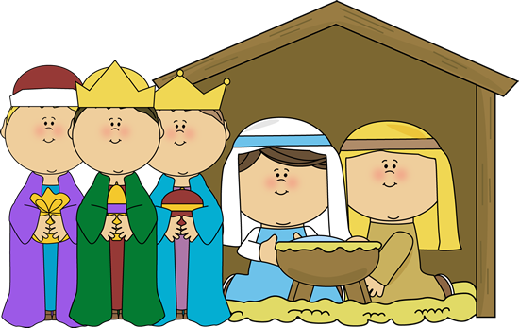
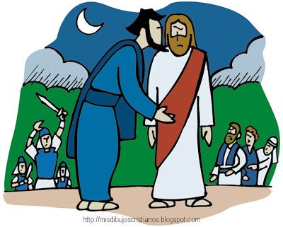
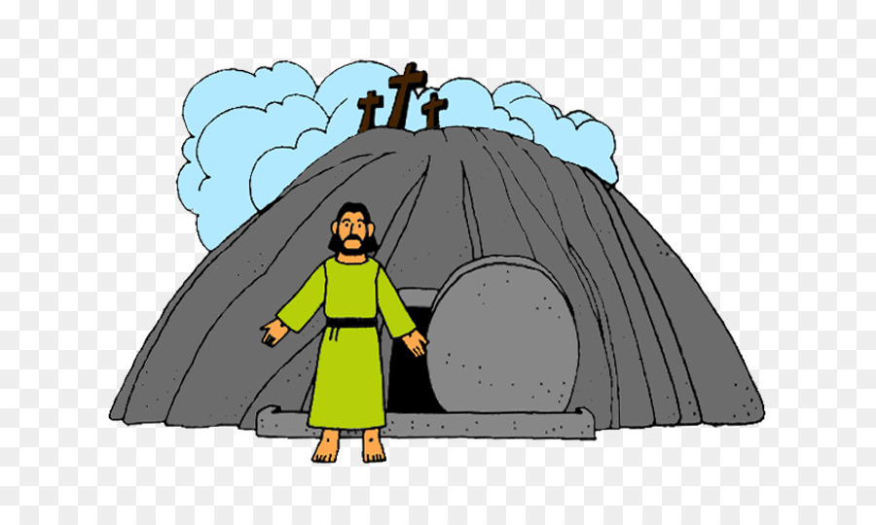

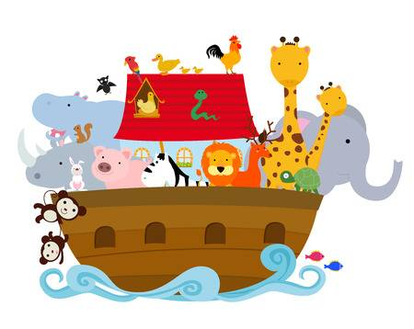  Noah and the flood | 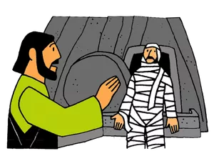  Jesus raises Lazarus from the grave
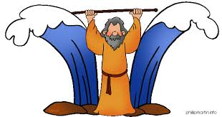  Moses | 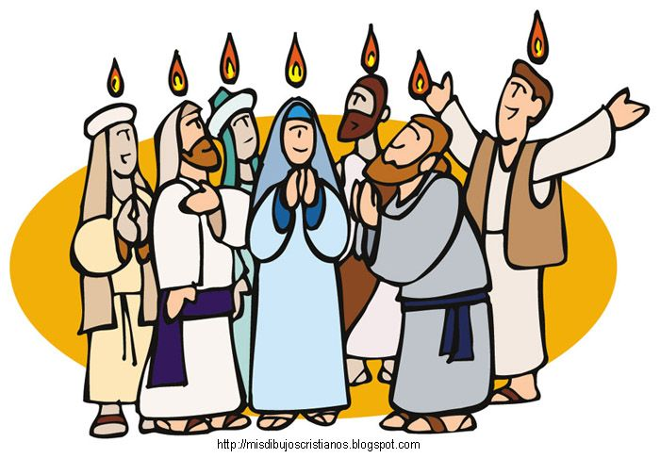  The Holy Spirit comes at Pentecost
Judas betrays Jesus | 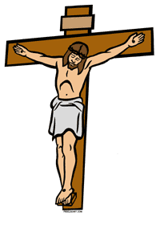  Jesus dies on the cross
Jesus is born | Jesus comes back to life
Adam and Eve | 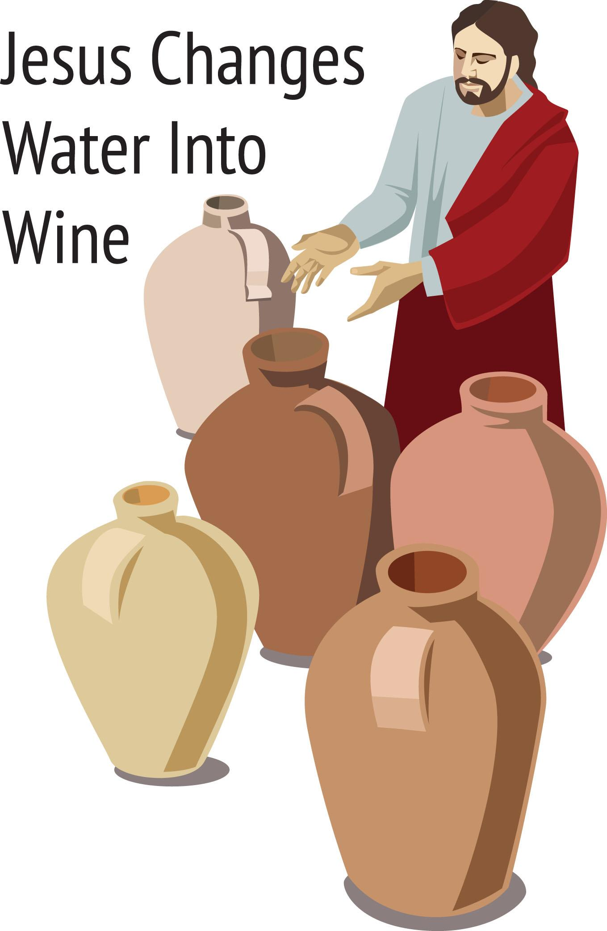
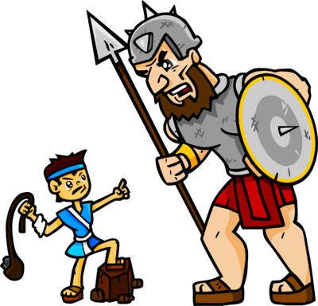  David defeats Goliath | Joseph and his brothers

